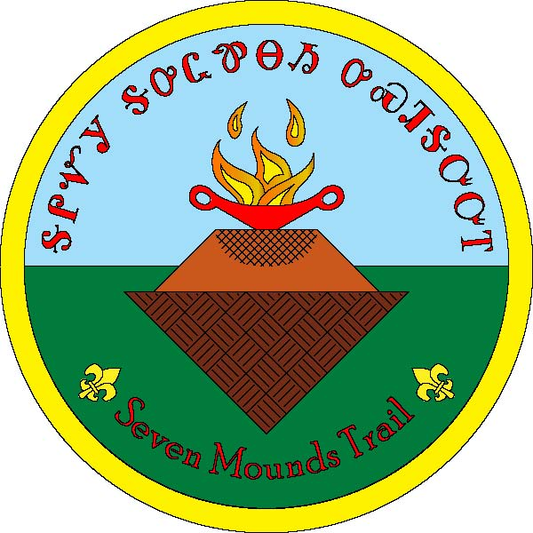
Great Smoky Mountain Council
Seven Mound Trail
Camp Buck Toms
Rockwood, Tennessee

Seven Mound Trail Evaluation Form
In order to better serve your program needs, please complete this form. Thank you
Unit Number___________________ Council __________________________________
Name: ____________________________________________________________
E-mail ________________________________________________________________
Date of Hike ________________
 | 1  Excellent | 2  Very Good | 3  Good | 4  Average | 5  Poor
Map
Directions
Recognition Awards
Your Hike
Trail Condition
Signs
Trail Marker
Overall Experience
Additional comments: Please describe any positive or negative experiences you have had and any changes or additions you would like to see in the future.

____________________________________________________________________________
____________________________________________________________________________
____________________________________________________________________________
____________________________________________________________________________
____________________________________________________________________________
____________________________________________________________________________
Great Smoky Mountain Council
Jane Manly Museum
Boy Scouts of America
1333 Old Weisgarber Rd
Knoxville TN 37909

janemanlyscoutmuseum@gmail.com

