Cades Cove District
Rocket Launch &
Shooting Sports Day!

Date: Saturday, September 25, 2021
Time: 9:00 a.m. until 12:00 p.m.
Location: Browder Farm
2701 US-11 Sweetwater, TN 37874
Cost: Free to new Cub Scouts
$5 for existing Cub Scouts

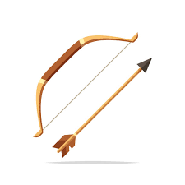

Come join us to for some scouting fun!

Please Contact your District Executive with any questions

Sr. District Executive: Austin Abee 423-920-4536

