Cades Cove District
Rocket Launch &
Shooting Sports Day!

Date: Saturday, September 25, 2021
Time: 9:00 a.m. until 12:00 p.m.
Locations: Partnership Christian Church
323 Partnership Parkway, Maryville TN 37801
Cost: Free to new Cub Scouts
Rocket Kits can be purchased for $5 for existing Cub Scouts, must get ahead of time to be able to launch at event.

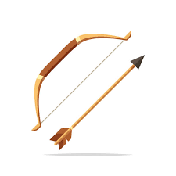

Come join us to for some scouting fun!

We have a fun day planned with a BB Gun Range and an Archery Range. Don’t forget your Model Rocket! All new Scouts will have the chance to launch their model rocket. We will be there from 9am to noon on Saturday so drop by and get your Scouting Adventure Started!

For Questions or to purchase a Model Rocket for an existing Scout please contact Geoff Cusick.

District Executive: Geoff Cusick 865-324-4608 or gcusick@scouting.org

