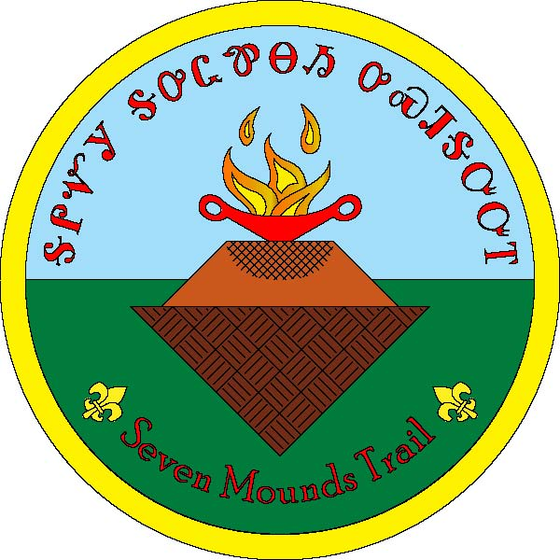
Great Smoky Mountain Council
Seven Mounds Trail
Camp Buck Toms
Rockwood, Tennessee

The trail is for those who want to learn more about the Native Americans peoples who inhabited the area that makes up the Camp Buck Toms and East Tennessee.

TYPE, LENGTH AND SEASON OF TRAIL:
Scenic and Nature, ~5.8 miles, open all year with exceptions noted in Council Calendar.

The trail must be hiked. (Physically challenged Scouts need not hike)

REQUIREMENTS FOR HIKING TRAIL:
You must be a registered Scout, Explorer, Venturer, Sea Scout, leader of the Boy Scouts of America, or accompanying family member.

At least two BSA registered adults must accompany any Scout Unit.

You represent BSA, so wear your uniform properly.

Follow the Guide to Safe Scouting.

Follow the principles of Trek Safely.

Follow the principles of Leave No Trace (LNT) and The Outdoor Code.

STARTING/ENDING POINT:
Jane Manly Museum

POINTS OF INTEREST:
Seven Indian Mounds
Beautiful rolling hills
Rugged trail

CAMPING: Yes, you must complete and submit Camp Buck Toms Short Term Camp Permit Application, if the camping is not part of a scheduled camping event. This form is found on the Council website.

TRAIL MAPS AVAILABLE: Yes

TRAIL WELL MARKED: Yes, there are trail signs, orange snow poles, and red flagging.

TRAIL MARKER DESIGN:
There are numbered signs along the trail explaining the trail and the sites. The test questions will reference the trail sign that has the answer.

GUIDES AVAILABLE IF REQUESTED: No

SOMEONE TO MEET HIKERS AT STARTING POINT IF REQUESTED: Yes

AVAILABLE AWARDS: Patch - Each participant must fill out their own questionnaire if capable. Present a completed Trail Questionnaire for each patch requested.

Medal - Scouts have satisfactorily completed all requirements for the Seven Mounds Trail Patch and have completed two hours of a trail service project that has be approved and scheduled in advance with the Trail Committee and Camp Ranger.

FOR MORE INFORMATION CONTACT:
Great Smoky Mountain Council
Jane Manly Museum
Boy Scouts of America
1333 Old Weisgarber Rd.
Knoxville TN 37909

Questions can be directed to: janemanlyscoutmuseum@gmail.com.

Website: https://www.easttnscouts.org/about/camps/buck-toms/seven-mound-trail/

Other Places to Visit:
Museum of the Cherokee Indian, in Cherokee, North Carolina - http://www.cherokeemuseum.org/
Sequoyah Birthplace Museum, in Vonore, Tennessee - http://www.sequoyahmuseum.org/
Red Clay State Historic Park, in southern Bradley County, TN - https://tnstateparks.com/parks/red-clay

