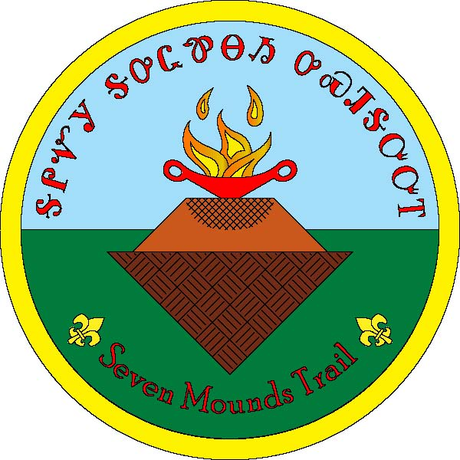
Great Smoky Mountain Council
Seven Mounds Trail
Camp Buck Toms
Rockwood, Tennessee

Seven Mounds Trail Evaluation Form
In order to better serve your program needs, please complete this form. Thank you.
Unit Number___________________ Council __________________________________
Name: ____________________________________________________________
E-mail ________________________________________________________________
Date of Hike ________________
 | 1  Excellent | 2  Very Good | 3  Good | 4  Average | 5  Poor
Map
Directions
Recognition Awards
Your Hike
Trail Condition
Signs
Trail Marker
Overall Experience
Additional comments: Please describe any positive or negative experiences you had and
any changes or additions you would like to see in the future.

____________________________________________________________________________
____________________________________________________________________________
____________________________________________________________________________
____________________________________________________________________________
____________________________________________________________________________
____________________________________________________________________________
Great Smoky Mountain Council
Jane Manly Museum
Boy Scouts of America
1333 Old Weisgarber Rd.
Knoxville TN 37909

janemanlyscoutmuseum@gmail.com

