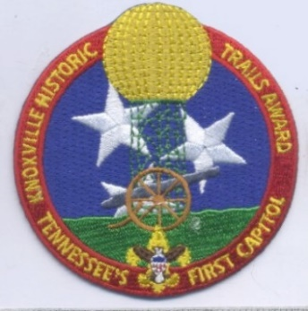
Great Smoky Mountain Council
Knoxville Historic Trails
Knoxville, Tennessee
The trail has been developed for the benefit of scouts and others who may have an interest in learning about Knoxville's role as the "Crossroads of America's Early Frontier.".

TYPE, LENGTH AND SEASON OF TRAIL:
Open all year

Main Loop – 2 miles
Fort Dickerson Loop- 3.1 miles
University of TN/ Fort Sanders Loop- 1.9miles
Old City Loop- 0.9 miles

The trail must be hiked. (Physically challenged Scouts need not hike)

REQUIREMENTS FOR HIKING TRAIL:
You must be a registered Scout, Explorer, Venturer, Sea Scout, leader of the Boy Scouts of America, or accompanying family member.

At least two BSA registered adults must accompany any Scout Unit.

You represent BSA, so wear your uniform properly.

Follow the Guide to Safe Scouting.

Follow the principles of Trek Safely.

Follow the principles of Leave No Trace (LNT) and The Outdoor Code.

STARTING/ENDING POINT:
James White Fort

POINTS OF INTEREST:
• Blount Mansion
• East Tennessee Veterans Memorial Association
• James White's Fort
• Knoxville Museum of Art
• Museum of East Tennessee History
• Sunsphere
• TN Woman's Suffrage Memorial
• Women's Basketball Hall of Fame

CAMPING: Yes, there are several public and private campgrounds in the Greater Knoxville area. Camp Buck Toms and Camp Pellissippi are both camp properties operated by the GSMC. If camping and or use of additional facilities are desired, then a Short-Term Camp Permit Application needs to be completed and submitted to the GSMC.

TRAIL MAPS AVAILABLE: Yes

TRAIL MARKED: No

GUIDES AVAILABLE IF REQUESTED: No

SOMEONE TO MEET HIKERS AT STARTING POINT IF REQUESTED: No

AVAILABLE AWARDS: Patch – A patch is available for hiking the trail and submitting the trail paperwork.

Medal - Scouts have satisfactorily completed all requirements for the for hiking the trail and all the loops and submitting the material in accordance with the trail paperwork.

FOR MORE INFORMATION CONTACT:
Great Smoky Mountain Council
Jane Manly Museum
Boy Scouts of America
1333 Old Weisgarber Rd.
Knoxville TN 37909

Questions can be directed to: janemanlyscoutmuseum@gmail.com.

Website: https://www.easttnscouts.org/

Other Places to Visit:
Confederate Memorial Hall (Bleak House) - http://www.bleakhouseudc89.org/
Old Gray Cemetery - https://oldgraycemetery.org/home
McClung Museum of Natural History and Culture -https://mcclungmuseum.utk.edu/
Mabry-Hazen House - https://www.mabryhazen.com/
Beck Cultural Exchange Center - https://www.beckcenter.net/

