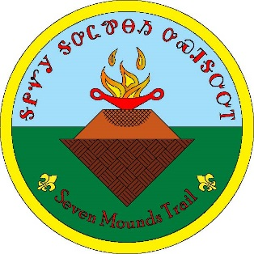
Great Smoky Mountain Council
Seven Mounds Trail
Camp Buck Toms
Rockwood, Tennessee
SEVEN MOUNDS TRAIL TEST
- Camp Buck Toms and the Seven Mound Trail - How many Scouts and Leaders attended the first year of camp? ___________
- Patch Design - The original design was by? ___________ ___________
- Sequoyah - How long did it take Sequoyah to create the Cherokee syllabary? ___________ years
- Long Hair Clan - The Long Hair are known as what type of clan? ___________ ___________
- Eastern Band of the Cherokee - What is the name of the outdoor drama the Cherokee also present and preserve their heritage? ___________ ___________ ___________
- Blue Clan - The Blue Clan's Subdivisions are? ___________ or ___________ and ___________
- Paw Paw - Tennessee's official butterfly is? ___________ ___________
- Cherokee Language - The syllabary originally included how many symbols? ___________
- White Oak - The Cherokee used the acorns for what? ___________
- Yonaguska - When did Yonaguska die? ___________ ___________
- Fire and Water - How many woods were used for the sacred fire? ___________
- Deer Clan - They were also known as what on an earthly level? ___________
- Junaluska - Where is Junaluska buried? ___________, ___________
- Existing Sign - The burial mounds were constructed in what period? ___________ ___________
- Bird Clan - The Bird Clan's Subdivisions are? ___________ ___________ ___________
- Wild Potato Clan - The Wild Potato Clan's Subdivision is? ___________
- Wolf Clan - Wolves are known as? ___________
- Cherokee Sacred Directions and Colors - We live in which direction? ___________
- Persimmon - Persimmon is in which family? ___________
- Paint Clan - Members of the Paint Clan were historically known as? ___________ ___________ ___________
- Sparkleberry - Sparkleberry was used to treat? ___________ ___________
- Water bars - Water bars redirect water where? ___________ the ___________
- Grading - On a properly graded trail the water should what? ___________ ___________ ___________

__________________ _________ __________
Signed by Participant Type/Unit Date

Test Valid from 10/26/2022 to 12/31/2024

