**How to update Troop Unit Metrics – Outdoor Activity**

To update the "Outdoor Super Activity" information in BSA Commissioner Tools, access the Unit Metrics section within My.Scouting.org's Organization Manager, then navigate to the Unit Dashboard and find the "Unit Data Metric Entry" tab. Enter the date of the outdoor activity and any other relevant details. This is typically done by a Key 3 leader within the unit.

Detailed Steps:

1. Log into [My.Scouting.org](https://my.scouting.org/): Access the [My.Scouting.org](https://my.scouting.org/) website.
2. **Navigate to Organization Manager:** Click on "Menu", select your unit, and then click on "Organization Manager".
3. **Locate Unit Metrics:** Within the Organization Manager, find the "Unit Metrics" tab.
4. **Find the Unit Dashboard:** Access your Unit Dashboard.
5. **Access Unit Data Metric Entry:** Locate the "**Unit Data Metric Entry**" tab, which is a new feature in the updated Commissioner Tools.
6. **Enter Activity Information:** Find the date field for outdoor activities and input the appropriate date (e.g., the start date for a multi-day event). Also, enter any other relevant information related to the activity.
7. **Confirmation:** If you are the Key 3 leader for the unit, you should be able to save the information and see the updated activity metrics in the system.

Quick Steps

1. Log into **My.Scouting.org**
2. Click on **Menu**
3. Click on **Organization Manager**
4. Click on **Unit Data Metric Entry**
5. Select the Date of Activity and add any details it requires.
6. Submit Entry

TROOPS



**1**

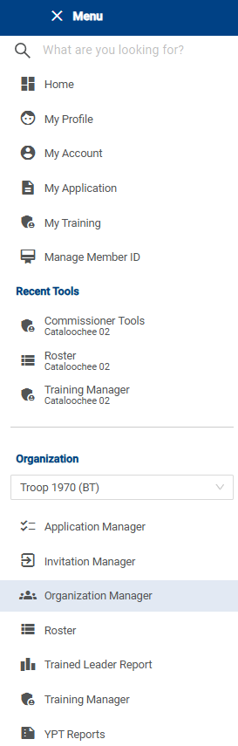 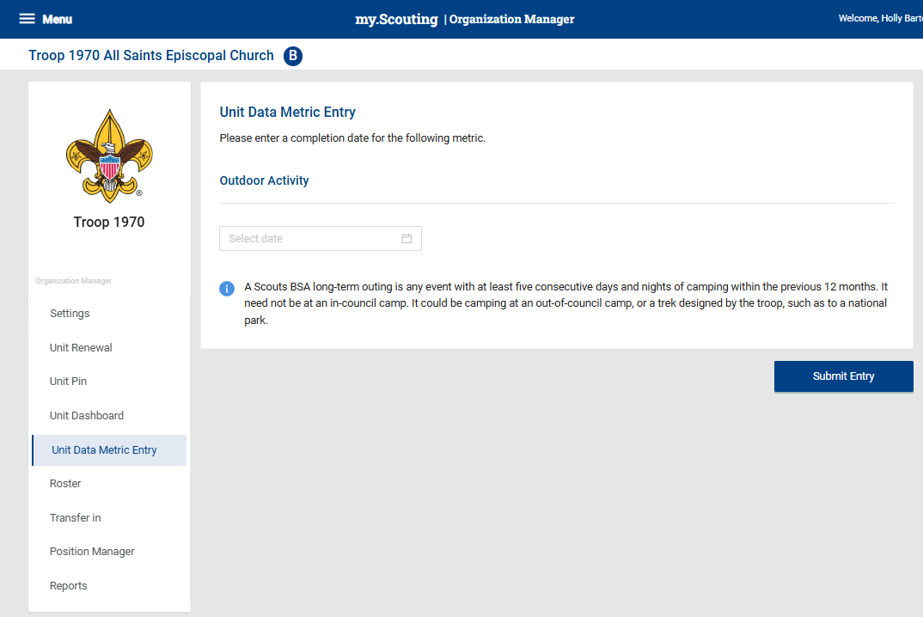

**5**

**4**

**3**

**2**